Capitalization of Local Agricultural Knowledge in the Fight against Soil Degradation: Experiences with Farmers of Bapa and Bamendjo in West Cameroon
Amavi de fer Anougué Tialefack^{a*}, Nobert Tohnain Lengha^{b}, Emile Temgoua^{c}
ªPh.D. student, Department of Rural Socio-Economy and Agricultural Extension, University of Dschang, Cameroon
^{b}Lecturer, Department of Rural Socio-Economy and Agricultural Extension, University of Dschang, Cameroon
^{c}Head of department, Department of Soil Sciences, University of Dschang, Cameroon
ªEmail: amavidefer@gmail.com, ^{b}Email: tohnole@yahoo.com, ^{c}Email: etemgoua1@yahoo.com

Abstract
Given the degradation of soils observed mainly by the decline in fertility, the use of agricultural techniques and practices based on organic inputs appears to be a healthy alternative. This study focused on the capitalization of local agricultural knowledge in the fight against soil degradation. The objective was to show the importance of taking peasant knowledge into account in the process of popularizing sustainable agricultural practices to combat soil degradation. We have indeed conducted observations with farmers in the villages of Bamendjo in the Bamboutos and Bapa in the highlands of the West Cameroon region. The study focused on a sample of 419 producers, identified through contacts and to whom we submitted questionnaires to all and interviews to 37 of them. The other source of data was obtained from desk research. These data were analysed and tested using flat sorts, cross sorts and Pearson correlations. We carried out a descriptive analysis presenting the results of the collection in a rough way and we used the Pearson correlation to cross the variables and test their homogeneity. A third source of data was obtained from the results of laboratory analyses, comparing soil samples taken between 0-20cm, 20-40cm and 40-60cm in two fields (1) and (2) exploited with techniques and different cultivation practices, one conventionally (1) and the other organically (2). The main results enabled us to retain the various indicators that show the contribution of peasant knowledge to sustainable soil management. More than 65% of the producers met had to develop knowledge enabling them to better develop their agricultural activities while contributing to the preservation of the soil. The results of the soil analyses showed through the proportions of certain properties, in particular Ca, CEC including the heavy metal content that the farm (2) has a higher level of fertility than that of the farm (1).
------------------------------------------------------------------------
* Corresponding author.
This proves that organic fertilizers increase the sustainability of soils over the long term. This study will focus more on traditional knowledge that seems better suited to local ecosystems. To this end, we recommend that the various public and private development actors set up agricultural extension programs and systems that take into account peasant knowledge.
Key words: Local knowledge; Soil; Peasant; Organic fertilizers; Rural; Degradation.
- Introduction
For a long time, the orientation was that of the appropriation of purely scientific knowledge and above all very distant from local realities. Peasant initiatives have been widely ignored and accused of being “thoughtless” even though they are said to be more sustainable than imported technologies. Today, there is no longer any doubt that the knowledge and know-how of the local populations of the South, generally supported by a strong social cohesion, testify to a functional flexibility of their production strategies, as a guarantee of their capacity to adaptation [1]. In Africa, the majority of the population practices agriculture and unfortunately farmers are the most vulnerable groups [2]. The agricultural models of the last fifty years have all favored the growth of yields leading to more or less significant damage to natural environments [3]. The colonial agricultural policy in Cameroon, as in the majority of African countries, placed great emphasis on the promotion of cash crops (cocoa, coffee, banana-plantain, rubber, oil palm), requiring material support in terms of inputs from synthesis (fertilizers and pesticides). In southern countries and in this case south of the Sahara, human activities can indirectly affect phenomena such as floods and bush fires [4]. Farmers very often have agricultural techniques and practices that are less favorable to the conservation of the soil layer. The strong dependence of agricultural and pastoral activities dependent on rainfall and therefore on the climate, explains the vulnerability of poor populations, in particular those living in rural areas whose means of subsistence depend essentially on agricultural activity [5]. The impact of climate change on agriculture is multiple and weighs on people, farm capital and less productive results [6]. Producers very often use their various traditional knowledge to overcome the various environmental shortcomings they face and guarantee their subsistence and that of their descendants. Taking into account indigenous “inside” knowledge would make it possible to correct the weaknesses of the soil, improve agricultural production and reduce the vulnerability of producers. Does the conservation of agricultural soils depend on taking local knowledge into account in the agricultural extension system? Farmers have fertilization and erosion control techniques favorable to sustainable soil management.
2. Methodology
2.1. Study area
The study was carried out in two villages located in two councils of two different divisions of the West region Cameroon, precisely in the village Bamendjo in the Mbouda subdivision and the village Bapa in the Bangou subdivision.
2.2. Sampling
The number of producers to be met was determined using the cross-quota sampling method, with producers grouped into several socio-professional categories and rural stakeholders, specifically farmers, members of civil society organizations and the heads of decentralized State programs and services. 1,102 producers were identified, including 536 women and 190 young people, who since 2015 have benefited from the support on agroecological production techniques, i.e. 576 in Bamendjo and 526 in Bapa (tab. 1).
Table 1: Number of producers supported since 2015
Villages | Bamendjo |  |  | Bapa |  |  | Total
Number of producers | Male | Fem. | Young | Male | Fem. | Young
 | 255 | 218 | 103 | 121 | 318 | 87 | 1102
Total | 576 |  |  | 526 |  |  | 1102
Proportionally to the size of the population of each village, we have n = [n1(Bamendjo) + n2(Bapa)]. Thus, according to the formula:
$n=\frac{{tp}^{2} x P\left(1-P\right)x N}{{tp}^{2}x P\left(1-P\right)+ \left(N-1\right)x y^{2}},$ $=\frac{{tp}^{2} x P\left(1-P\right)x 576}{tp² x P\left(1-P\right)+ \left(576-1\right) x y²}$ + $\frac{{tp}^{2} x P\left(1-P\right)x 526}{tp² x P\left(1-P\right)+ \left(526-1\right) x y²}$ = 230, 69 + 222, 25 = 453, (1)
within a 95% confidence interval, with tp = 1,96 for P = 0,5.
However, given the difficulties of access for certain households and neighborhoods in rainy weather and because of the high mobility of populations towards the countryside during long stays for rural and hunting activities, we were able to interview a set of 419 producers, i.e. 38% of the target population. (tab. 2).
Table 2: Number of producers met
Villages | Bamendjo |  |  |  | Bapa
 | Adults |  | Young |  | Adults |  | Young |  | Total
Number of producers | Male | Female | Boys | Girls | Hom | Female | Male | Girls
 | 97 | 83 | 18 | 21 | 46 | 121 | 18 | 15 | 419
Total | 180 |  | 39 |  | 167 |  | 33 |  | 419
 | 219 |  |  |  | 200 |  |  |  | 419
Thus, in the locality of Bamendjo, the sample corresponds to 44% of men, 38% of women and 18% of young people, while in Bapa, 23% of men, 60% of women and 17% of young people were investigated. Agricultural techniques and practices favorable to soil sustainability have been identified, analyzed, evaluated and characterized in a participatory manner using SWOT matrices through exchange and sharing meetings.
Soil samples were also taken from a composite sampling, in two farms with different agricultural practices, one (Farm 1) located at the bottom of a slope between 1300 m and 1307 m above sea level and almost flooded, on an area of ​​2.5 ha exploited with the use of synthetic chemicals for the cultivation of market gardeners (peppers, tomatoes, cabbage) and the other (Farm 2) located on the slope between 1315 and 1318 m above sea level, on an area of ​​1900m² in which only organic inputs are used for the cultivation of food crops like beans (Phaseolus vulgaris L), cocoyam (Xanthosoma sagittifolium) and melon (Cucumis melo). The samples were taken around 3 quadrats comprising 15 survey points in farm 1 and 2 quadrats comprising 10 survey points for farm 2 (fig. 1).
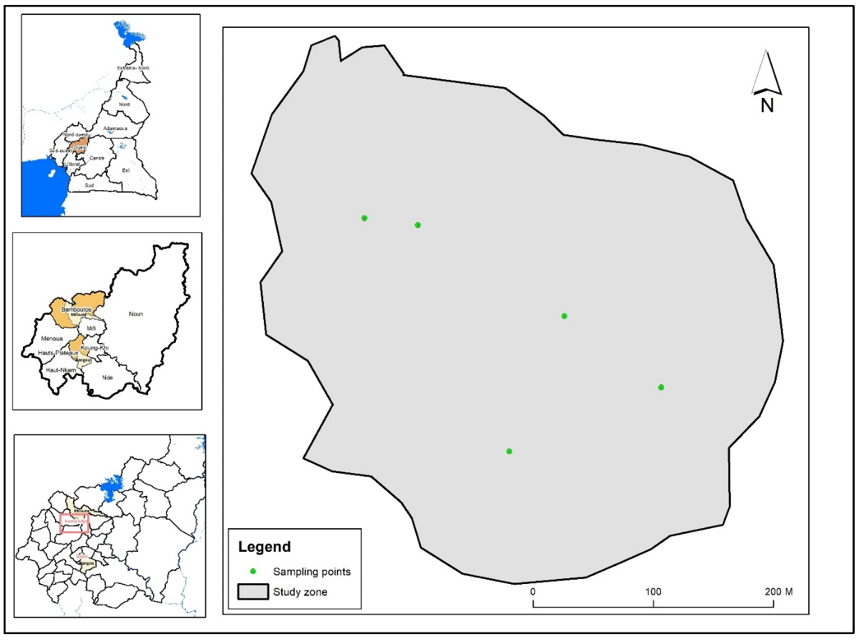
Figure 1: Location map of sampling points
2.3. Data collection and analysis
Data was collected from questionnaires, interview guides and observation grids. They were analyzed using SPSS software for data collected from producers and laboratory analysis for soil sample data.
- Results and discussion
  - Socio-economic impact of precarious agricultural soils
    - The decline in productivity
Soil degradation has a negative impact on production. It reduces soil fertility and also limits plant growth. For several years, farmers have been complaining about the poverty of the soil which no longer produces enough and also about the derisory quality of the harvests, which is the source of widespread famine and the precariousness of living standards. Technological changes, rather than the increase in rural population as well as agricultural intensification linked to the desire to increase crop yields, have led to land degradation [7].
    - The disappearance of traditional species
Several village species once useful for human food are endangered or almost extinct for the most part today. For a long time, the invasion of cultures from elsewhere through exploration and colonization led to the abandonment of local cultures of yesteryear, of ancestral origin, yet with nutritional and therapeutic virtues. Also, the use of synthetic chemical fertilizers and pesticides has considerably contributed to denaturing the soils and the ambient environments to which the growth of these local plants was accustomed. These are essentially vegetables, cereals, tubers which, in addition to being nutritious, also make it possible to prevent, manage or treat certain diseases in humans such as diabetes, blood pressure or amoebas. Some of these species have been identified from producers in different villages (tab. 3).
Table 3: Some endangered local species
Espèces | Classification | Role | Observation
Tsetsè | Vegetable | Calcium intake  Controls diabetes  Regulates voltage | On the way out
Felah | Vegetable | Used as a dewormer in humans | almost disappeared
Feufèh | Vegetable | Regulates voltage  Controls diabetes | almost disappeared
Ngwoûh | Tuber | Controls diabetes | almost disappeared
Loungh | Tuber (long-haired yam) | Controls diabetes | almost disappeared
Metough | Tuber (dana) | Controls diabetes | On the way out
Source: Producers from Bapa and Bamendjo villages
Faced with this crisis marked by the loss of cultural identity, the majority of producers feel defeated and only a few are considering rescue attempts to recover certain species. However, these are not very effective strategies so far. Because some measures just consist in transplanting the species threatened with extinction, without thinking about their multiplication or their extension in other farms. In the Bapa village in this case, the disappearance of the long-haired yam called loungh has disappeared because of the difficulty encountered by the peasants in its cultivation. According to their complaints, the loungh when planted in the ground, grows by burying its long roots and subsequently becomes difficult to harvest. This has led some producers to cultivate this plant on the rocks which they simply cover with earth, so at harvest time they simply clear the mass of earth to pick up the tuber.
  - Local fertilization techniques favorable to soil sustainability
3.2.1. Farmer fertilization based on organic inputs: case of 21-day compost
Producers have all learned to make at least one fertilizer from organic debris, such as 21-day compost and compost. At least 57.6% of producers know the techniques of making 21-day compost and compost. However, 66% of producers say that yields are higher and more satisfactory with 21-day compost than with compost, which requires more time to reach maturation.
Local production of 21-day compost
The 21-day compost, commonly called biochar in localities (bio chacoal or biological charcoal) is an organic fertilizer produced from the decomposition of plant and/or animal matter under a limited supply of oxygen and considerably reinforced in micro- organisms.
21-day compost associated with a supply of organic matter and other mineral elements is of agronomic and environmental interest for producers. The elements that go into the composition of 21-day compost are natural, not toxic to plants or humans, and therefore do not produce any harmful effects for the environment. 21-day compost is made up of charcoal obtained by carbonization of biomass, animal manure such as chicken droppings, bokashi, leaves of Tithonia diversifolia (“jealousy” flowers) and Effectiveness Micro-organisms (EM).
To produce 90 kg of 21-day compost, i.e. 3 bags of 30 kg each, you need 15 kg of charcoal, 50 kg of droppings, 4 kg of bokashi, 225 ml of EM, approximately 15 liters of water and 15 kg of leaves of Tithonia diversifolia. During manufacturing, CIPCRE provides material support to each producer. The kit of materials for each producer consists of a bag of manure, a bottle of EM, 4 kg of bokashi, a bag of powdered charcoal and 3 nylon bags. The manufacture of 21-day compostis done in 4 successive stages as follows:
1st step: Preparation and cutting of the Tithonia leaves. After spreading the plastic tarpaulin on which the operation takes place, the leaves of jealousy flowers are cut with the other leaves picked into small cuts, using the machete on a slat on the tarpaulin to avoid losing this precious organic material (fig. 2).
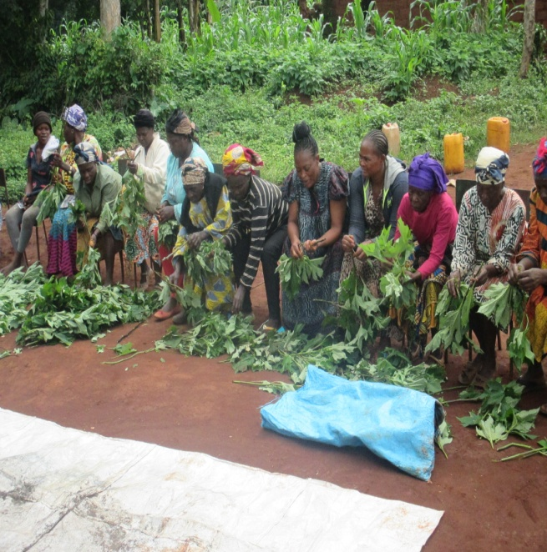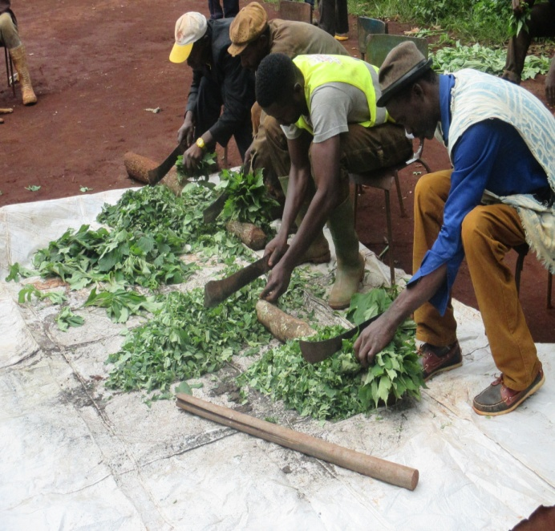
Figure 2: Preparation of tithonia leaves by women and cutting by men.
Step 2: Mix droppings and charcoal. When the tithonia leaves are cut, they are mixed with charcoal and animal manure on a tarpaulin, while taking care to destroy any clods that may have formed (fig. 3).
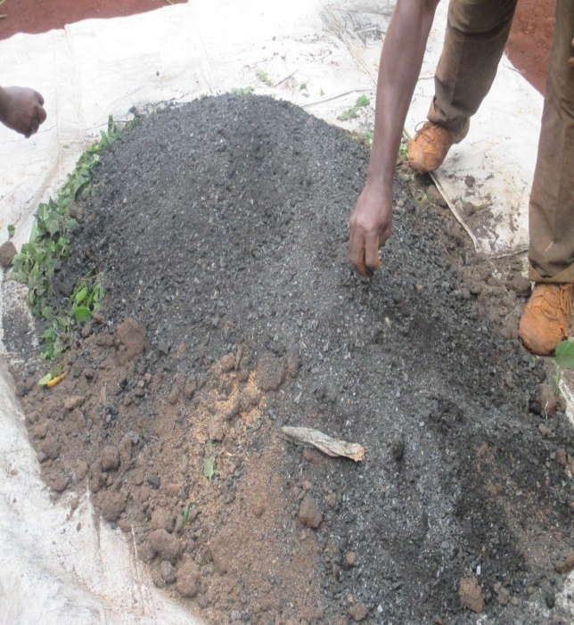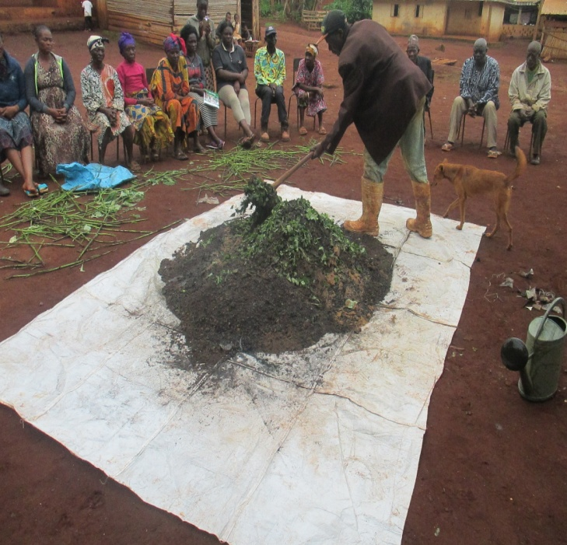
Figure 3: Mélange des feuilles de tithonia au charbon et au fumier animal.
Step 3: Add bokashi and EM. After the droppings are stirred with charcoal, 4 kg of bokashi are added to the mixture. Then, 3 cans of tomato serve as a measure for a quantity of 225 ml of EM which is poured into a watering can of 15 liters of water. Then this water diluted with EM is poured over the complete mixture and stirred continuously, checking to the touch if the product becomes a little sticky (fig. 4).
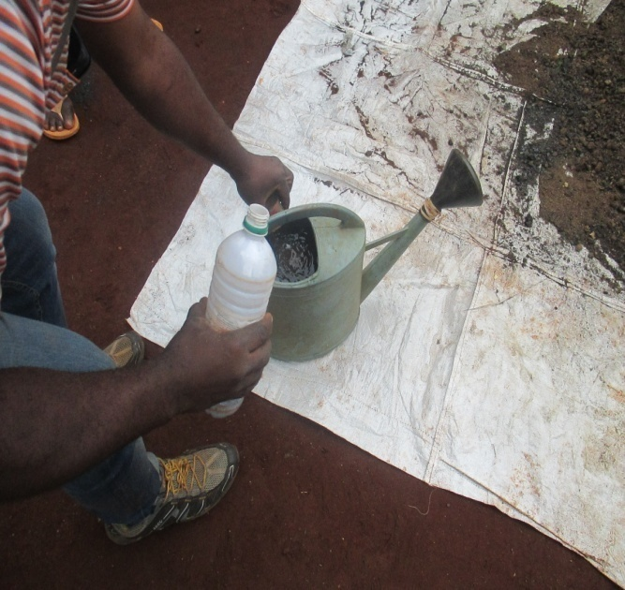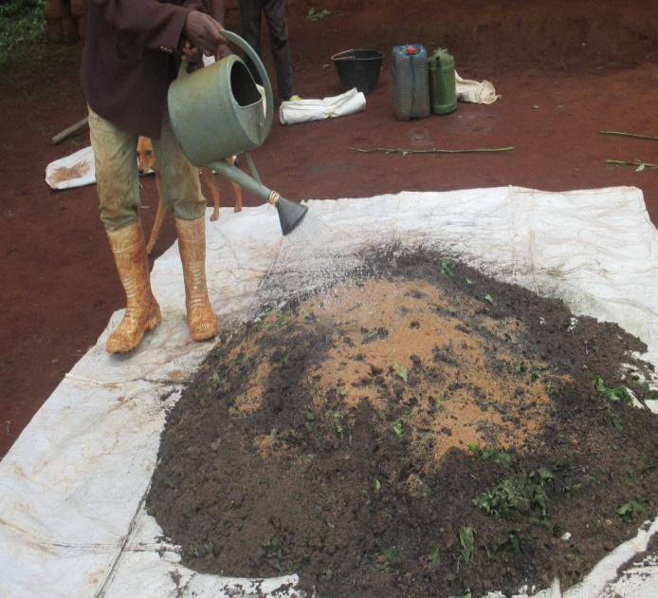
Figure 4: Adding EM and bokashi to the mix (tithonia+coal+manure).
4th step: Riddling and Bagging. After all the assured mixes, the 21-day compost is put in nylon bags. The bagging is done carefully to avoid piercing the nylon because the 21-day compost must ferment in the absence of air for a period of 21 days after its manufacture before being used. The bag of 21-day compost should be firmly attached and should not be completely filled. It should be kept out of direct sunlight and moisture while the fertilizer is maturing (fig. 5).
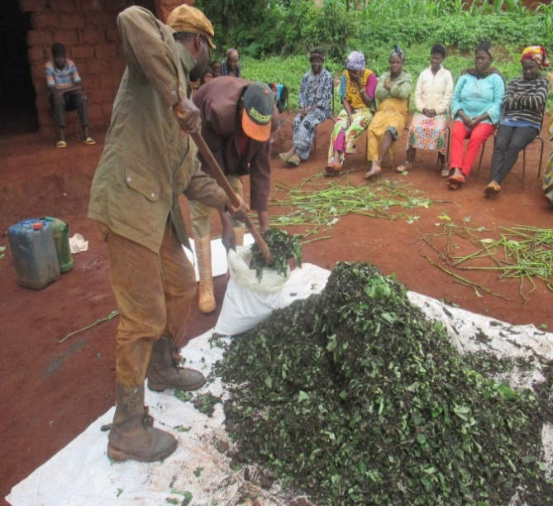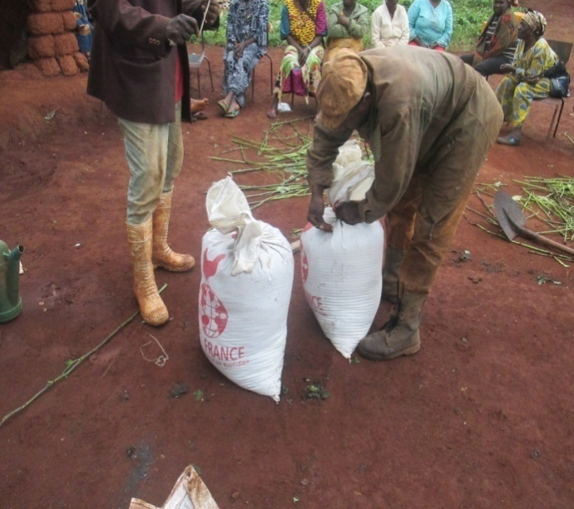
Figure 5 : Riddling and bagging of the manufactured 21-day compost for fermentation.
Application of 21-day compost on plants. In figure 6 below, the producers of the GNOVIDEB association fertilize their common farm based on mature 21-day compost. The application is done by poquet at the feet of the plants and the quantity administered to each plant depends on the size of the plant.
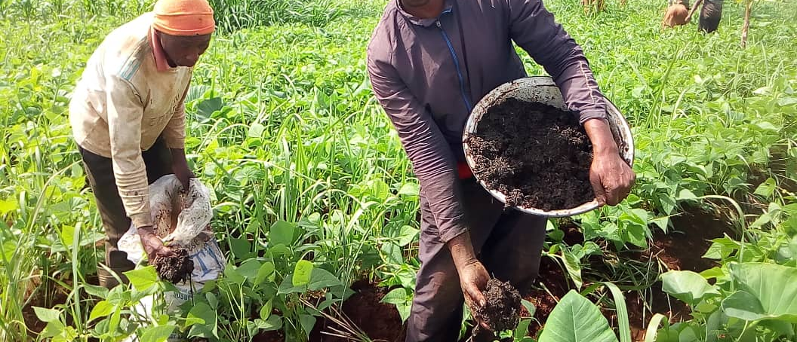
Figure 6: Application of 21-day compost on bean and macabo feet in Bamendjo
Effects of 21-day compost on cultivated soils
The 21-day compost has a dual role, both agronomic and environmental [8]. From an environmental point of view, it amends and improves the physico-chemical aspect of the soil by increasing its water and nutrient retention capacity. Also, it increases the pH of the soil useful against acidification. From an agronomic point of view, the 21-day-old compost promotes an increase in the rate of organic matter in the soil through the phenomenon of regulated and slowed down mineralization. It helps to strengthen the biomass of the soil microflora.
The results of a recent analysis carried out on a sample of 21-day compost sent to the laboratory made it possible to evaluate its content and its protective capacities. The analysis was carried out by the Soil Analysis and Environmental Chemistry Laboratory of the University of Dschang (tab.4).
Table 4: Results of analysis of 21-day compost properties
Content and physico-chemical properties | Quantity
Physical measurements
Da (g/cm³) | 0,42
P (%) | 84,34
SS (m²/g) | 211,85
Soil reaction
pH-H₂O | 5,7
Organic materials
CO (%) | 45,19
MO (%) | 77,90
N (g/ kg) | 3,77
C/N | 12
Exchangeable cations (mg/kg)
Ca | 4640
Mg | 826,2
K | 588,2
Na | 82,2
S | 6136,6
Cation exchange capacity (cmol (+) / kg)
CEC | 67,68
Total phosphorus (mg/kg)
Ptot | 345,0
Table 4 shows the properties that 21-day compost contains. 21-day compost contributes to the amendment, fertilization and regeneration of the soil thanks to its physico-chemical properties. The porosity of the 21-day compost makes it possible to retain water and slow down potential evapotranspiration in the soil. 21-day compost increases the nutrient ion exchange capacities in the soil. With supplemental and exchangeable cations, 21-day compost increases soil pH for optimal phosphorus availability.
3.2.2. The practice of integrated farming systems
Cultivation systems that are harmful to the environment are to be discouraged, and it is the concern of CIPCRE which promotes sustainable cultivation practices through its various awareness-raising and training courses. The main agricultural techniques that are shared with producers refer to the association of trees, the association of several crops and small livestock (fig. 8).

Figure 7 : Proportion of producers trained in sustainable farming practices
The promoted production systems adopted by the peasants of West Cameroon integrate the triangular correlation between man, plant and livestock. It is an agro-anthropo-pastoral association that consists of using household waste, pig and chicken droppings, especially livestock droppings, as organic manure for the farms. In return, the crops are intended for human consumption and the residues from the farms are used as animal feed. This integrated production system limits expenses and promotes organic farming (fig. 9).
Purchase / Rental of arable land
Seeds

Workforce
Farm
Crop residues for breeding, feed
Saving seeds from harvest
Valorization of household waste as manure
Harvests
Roots,
Tubers, fruits/vegetables
Households
Consumption of leftovers from the sale,
Production of household waste
Breeding
(Pigs, chickens, goats)
Production of droppings, organic manure for agriculture
Capital
Sales revenue
Tontines
Bank loans
Transformation/
Conservation
Flour, Dough, Starch, Grains
Market
Sale of products from livestock and processed or direct fields
Sale of droppings and by-products
Less strong action
Strong action

Figure 8: Model of the integrated farming systems of the Bapa and Bamendjo villages
The production system adopted by the peasants of the Bapa and Bamendjo villages of the West Cameroon region is favorable to the recycling of resources, because it makes it possible to create an interrelationship between agro-pastoral activities and man without strong dependence on inputs chemicals. Most producers in the west practice both agriculture and animal husbandry. Even though they have been farmers for the majority, they also do small livestock. This breeding allows them to produce droppings and organic manure through animal waste useful for plants. In return, crop residues are used for animal feed and also to fertilize the soil. The products of the farms and livestock are primarily intended for the market and the leftovers can be consumed in households which in turn sort their household waste for animal feed and manure in the farms.
The majority of producers do mixed crops and the type of associations varies from one producer to another. Associations range from two to four crops on the same farm. The most cultivated products are: maize, beans, tomatoes, cabbage, groundnuts, potatoes, eggplant, okro, pistachio, black nightshade, carrots, banana, plantain, coco yam, yam, potato, pepper, watermelon, chilli, sugar cane, cocoa, koki and fruit trees
  - Fight against attacks and pests using natural pestifuges
Several pesticides are promoted from the plants and materials of the producers, in this case manure from tephrosia vogelii, fodder, pepper, tobacco, eucalyptus, garlic, ash (cooking), and comfrey. These natural pesticides are added to the cultivation of medicinal plants widely practiced in the villages and they distinctly play the roles of stimulant, fungicide, insecticide or repellent against the various attacks that destroy plants.
    - Plants liquid manure
The most popularized plants are tithonia diversifolia, fern, comfrey and tephrosia vogelii. Their advantage lies first of all in their availability, as they are ranked among the weeds that flood roadsides and farms in the locality. These plants are not edible, and therefore do not run the risk of being discussed for human consumption. Fern is the bio-pesticide that has been popularized the most compared to comfrey and tephrosia vogelii, because 37% of farmers claim to have participated in workshops for the manufacture of fern manure under the support of CIPCRE and other specialized organizations in the promotion of agroecology (fig. 10).

Figure 9: Types of natural pesticides most used by growers
The emphasis on this bio-pesticide is explained by the multiple roles it plays. The fern is both an insecticide that destroys aphids and an antifungal mulch against gray rot, useful for all kinds of crops and ideal for ground cover. It is also a natural slug repellent, because when used as a mulch around crops, it ferments, producing a substance toxic to slugs and snails that devour the plants. The fern is also a real green manure rich in nitrogen and phosphorus which fights against the acidity of the soils on which it grows. It must be incorporated into the soil after it has been used as mulch. Above all, it should be noted that it is a plant that grows almost everywhere in these villages. It is more available and more accessible by producers than tephrosia vogelii or comfrey. This is why producers mobilize in large numbers when it comes to a training session on its manufacture. The fern grows in the farms in abundance, even along the roads (fig. 11).
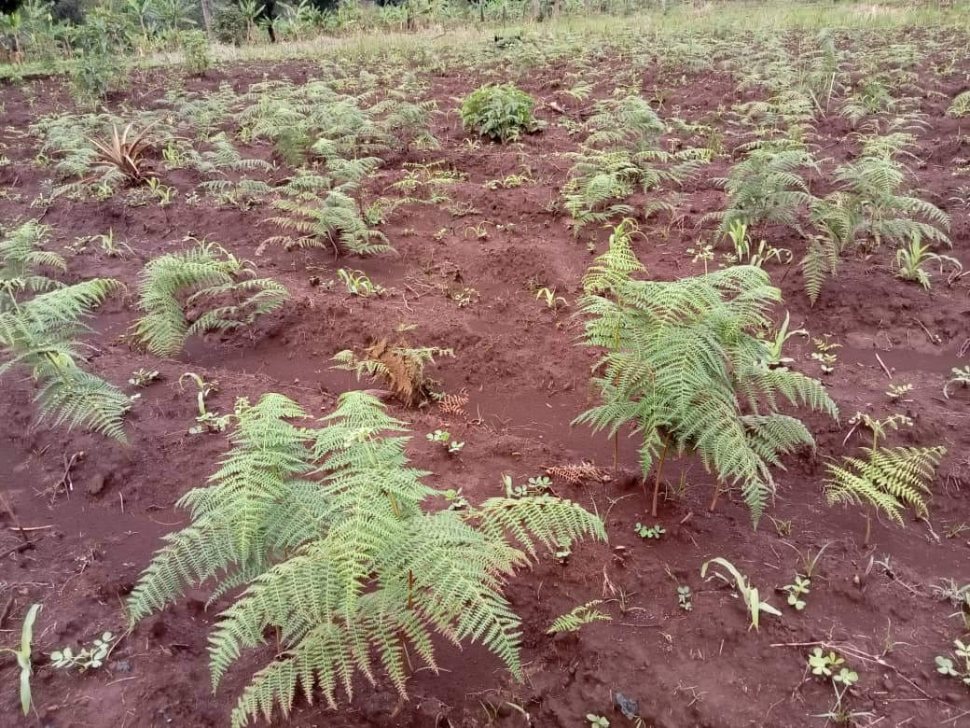
Figure 10: Fern plants on a farm in Bamendjo
CIPCRE also supervised 37 producers in the manufacture of comfrey manure and 28 other producers in the manufacture of tephrosia vogelii manure. Comfrey or symphytum officinale is an aphid insecticide that can also be used as a compost activator or foliar fertilizer. It has been popularized more than tephrosia vogelii which is also a very important insecticide for the protection of stored cereals and for the protection of domestic animals against aphids. But tephrosia is however dangerous for the skin of humans and for the health of animals if they were to inhale it. The manure most used just after the fern remains the tithonia diversifolia which is also found almost everywhere.
3.3.2. The use of wood ash as an insecticide
Farmers also use wood ashes to fertilize their farms or to control caterpillars and other harmful insects. It is also very effective in manure. Some farmers use the ash as an herbicide, especially to destroy the strains of sissongho (Penecetum purpurum). Ash powder is very often used by spreading it on the ridges around the plants or the trunks of banana-plantain trees (fig. 12 and 13).
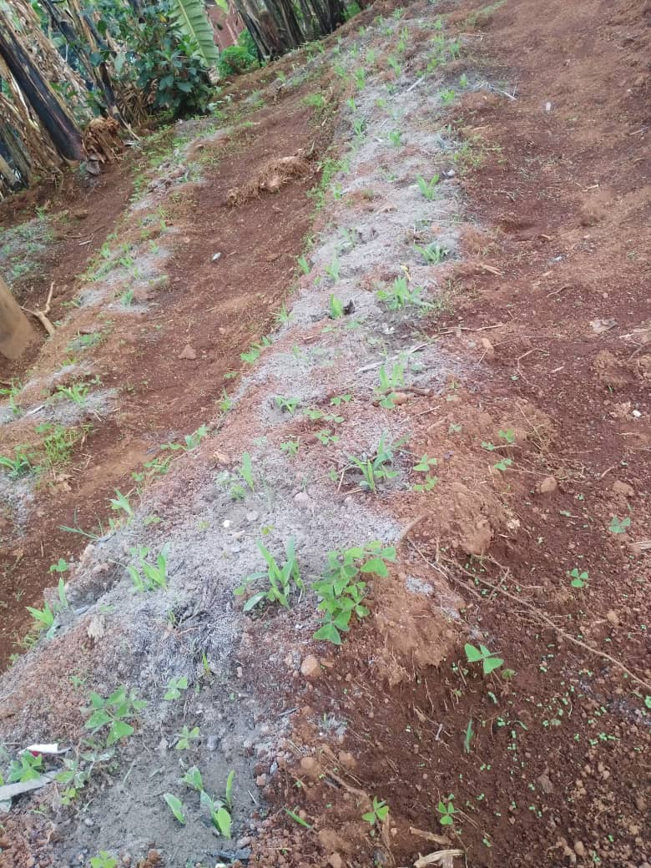
Figure 11: Use of wood ash on young maize-bean plants in Bamendjo
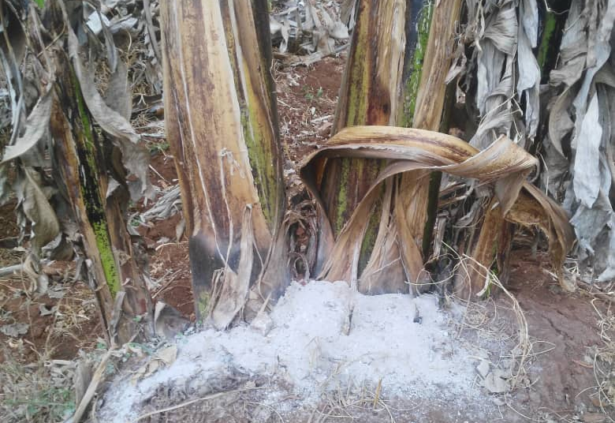
Figure 12: Kitchen wood ash piled up on banana-plantain plants in Bamendjo
The ashes contain on average 12% of unburnt organic matter, but this quantity is very variable. Ash has a significant impact on soil pH, it is used to neutralize soil acidity. It is administered by spreading, taking into account the AVI (Agricultural Value Index) of the liming amendment, analysis of the soil, its texture and the depth of incorporation [9]. The use of wood ash in composting materials and potting soils can be useful to adjust the pH and enrich the mineral content of the resulting products. The quantities must however be well dosed to achieve the quality objectives of the soils and the targeted pH. Ash rich in carbonized organic matter is the most suitable [10], because it has the effect of reducing odors during composting while giving a beautiful dark color to the compost (ibid. [9]).
The authors in [9] argue that wood ash is one of the most effective and least expensive fertilizers that can be used in organic farming as a source of potassium, phosphorus and sulphur. It is particularly appropriate in agro-organic systems where the supply of nitrogen ultimately depends on legume crops. In addition to wood ash, farmers develop their tricks around several other plants as described below (tab. 5).
Table 5: List of bio-pesticides used by the producers met
Category | Role | Use
wood ashes | - Prevents damping off and fungal attack  - Herbicides against strains of sissongho (Pinnesetum Purpureum)  - Neutralizes soil acidity | Spreading on the ground
Tobacco | Control of aphids, weevils, whitefly, caterpillars, bean rust | Spraying a decoction on the plants
Pepper | - High content of active substances  - Control of aphids, caterpillars and insects | Curative treatment by spraying chilli powder mixed with water
Fern | - Insecticides  - Anti fungal paddle  - Natural slug repellent | - Liquid manure spraying  - Ground cover  - Fresh or dry mulch about 5cm thick
Eucalyptus | - Insect repellent  - Fight against potato moth  - Insecticides and fungicides | - Insert 10 to 20 leaves for 1 kg of beans  - Make a litter of its leaves on which the tubers will be placed  - Spray a decoction on the plants
Garlic | Fongicides, nématicides, bactéricide contre les tiques | - Use of the pure decoction as fungicides  - Spray 0.5L of a decoction diluted in 15L of water as insecticides
Onion | Insecticides | - Spray an onion extract diluted with 3 times its volume of water
Comfrey | - Rich in vitamin B12  - Insecticides | -Decoction spray against whiteflies and aphids  - Spraying comfrey manure diluted to 95%
Tephrosia vogelii | - Insecticides  - Protection of stored cereals  - Protection of domestic animals | - Spraying  - Mix the powder and cereals  - Wash the animal with the juice of the leaves
3.4. Traditional methods of erosion control
Rural producers in the Western are aware of the uneven relief of their spaces and for the most part, techniques have been developed according to the degree of the slope on which they are located. The practices include the proper arrangement of ridges (perpendicular to the plant), the fencing of farms and habitats with live hedges and the cultivation of fruit trees.
3.4.1. The suitable ridging system
Faced with the rugged terrain of the village of "rocks", the producers of Bapa adopt ridging systems adapted to the type of slope on which they have to deal. This makes it possible to avoid unevenness and leaching of the layers of earth by the effect of runoff of rainwater. Very often, the ridges are perpendicular to the slope, as seen in the photograph (fig. 14).
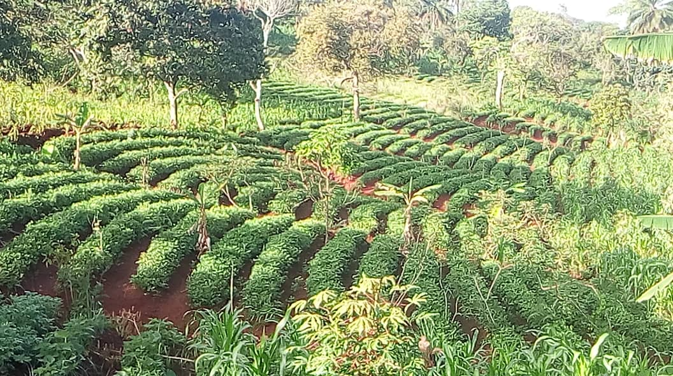
Figure 13: Arrangement of ridges perpendicular to the slope in a farm in Bapa
But these ridges perpendicular to the slopes of Bapa are insufficient to stop the erosion. They have only a limited impact on runoff and rarely follow contour lines. Also, when they are too long, breaking points are created which open the way to the beginning of linear erosion during very heavy rains.
A few living hedges made up of various species could have some effectiveness. However, they only concern plots close to dwellings, ie on low slopes and owned. In addition, they are mainly established in fences and are therefore not arranged in a contour line. Their main role is to fight against animal theft and wandering. The species used are not palatable to livestock and produce little biomass.
In Tigray in northern Ethiopia where soil moisture has been identified as the most limiting factor in agricultural production and where paradoxically the loss of rainwater and soil through runoff has been identified as a problem criticism in the region. The government has mobilized communities and resources for the construction of physical soil and water conservation structures (stone bunds, terraces) in almost all land uses. However, the yield improvement was mostly concentrated close to the structures and the runoff continued to overflow the structures as no in situ soil conservation measures were taken. Furthermore, traditional plowing followed by contour furrowing has been considered and evaluated as a practice likely to increase the efficiency of in situ water use and soil conservation [11]. An experiment was conducted in Gum Selasa, which is one of the drought-prone areas of Tigray, in which the runoff volume and sediment load were measured after each rainfall event. Permanently raised ridges significantly reduced runoff volume, runoff coefficient and soil loss compared to traditional tillage (ibid. [11]).
Overall, contour ridges and raised ridges can be part of soil and water conservation methods, reforestation of slopes, irrigation development and agroforestry in cropland. In addition, the use of permanent raised beds, if combined with mulching and crop diversification, is an important element for the development of sustainable conservation agricultural practices [12, 13].
3.4.2. The establishment of living hedges
The technique of living hedges, long attached to the Bamileke civilization, is one of the peasant weapons in the fight against erosion. By practice, the properties were originally framed by fences in order to avoid malevolent penetrations whether from people with bad intentions or from wandering beasts who could destroy their crops. These fences that surrounded habitats or farms were mostly made of local plant material, in particular living hedges or eucalyptus trees, and they consequently made it possible to protect the layers of earth against water runoff. Although this local practice tends to no longer be frequent due to the modernization and neglect that is invading current generations, it is still coveted by some peasants who wish to maintain the tradition they inherited from their parents. This is evident from the figure below which shows a peasant property in the King place district of the Bamendjo village where a family concession and a family farm located on the slope are protected by the hedgerow fence, locally called nkeng or tree of peace, symbolic of non-nuisance (fig. 15).
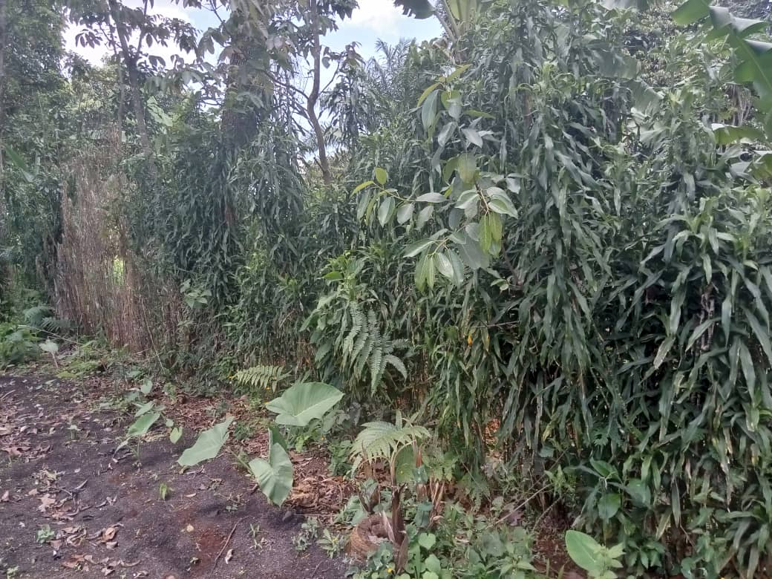
Figure 14: Fence of a family farm using quickset hedges. Bamendjo 2020.
3.4.3. Agroforestry practice based on fruit and honey trees
The introduction of trees into the cropping system has a capital contribution. Thanks to its roots that go very deep into the ground, the tree has the ability to go deep into the ground to seek nutrients for the plant. These nutrients are transported from the soil from the roots to the leaves which are then dumped on the ground to nourish them and nourish the plant. The trees most used by producers are melliferous shrubs such as caleindra and acacia, fruit trees such as avocado and plum (safoutier), plantains and vegetables such as tithonia diversifolia, vernonia.
The choice of trees is guided by their strong economic potential first and then ecological. Fruit trees are therefore more in demand, especially when they can also be used for beekeeping and the collection of kitchen wood. In Bamendjo village in Mbouda, producers adopt the cultivation of at least one avocado tree in their farm. By associating the trees in the farm, they make it possible to retain the rate of CO₂, and to limit the effect of erosion.
  - Contribution of organic fertilizers to the soil sustainability
By making a comparative analysis between two farms 1 and 2 of the Bamendjo village to determine the level of soil degradation due to the use of synthetic chemical inputs, we were able to identify the impact of synthetic chemicals on the soils as shown in the summary of the analysis results below (tab. 6).
Table 6: Summary of soil characteristics by type of agricultural practice
Features | Type of farming | Depth
 |  | 0 – 20 cm | 20 – 40 cm | 40 – 60 cm
CO% | With chemicals | 5,13 | 2,52 | 1,84
 | Organic | 2,24 | 1,92 | 2,05
N% | With chemicals | 0,29 | 0,18 | 0,08
 | Organic | 0,16 | 0,12 | 0,06
C/N | With chemicals | 17,72 | 15,91 | 24,02
 | Organic | 13,48 | 15,93 | 46,94
OM% | With chemicals | 8,85 | 4,35 | 3,16
 | Organic | 3,86 | 3,31 | 3,53
P(mg/kg) | With chemicals | 16,79 | 15,22 | 5,04
 | Organic | 13,25 | 10,35 | 3,78
PH eau | With chemicals | 6,9 | 6,7 | 6,9
 | Organic | 6,6 | 6,7 | 6,8
pHKCl | With chemicals | 5,7 | 5,8 | 5,8
 | Organic | 5,7 | 5,8 | 5,8
K(méq%) | With chemicals | 0,76 | 0,80 | 0,60
 | Organic | 1,60 | 2,83 | 1,45
Na(méq%) | With chemicals | 0,33 | 0,33 | 0,38
 | Organic | 0,28 | 0,55 | 0,42
Ca(méq%) | With chemicals | 7,39 | 5,79 | 5,23
 | Organic | 9,88 | 7,59 | 6,16
Mg(méq%) | With chemicals | 6,24 | 4,96 | 3,20
 | Organic | 6,68 | 3,85 | 3,68
SBE(méq%) | With chemicals | 14,72 | 11,87 | 9,41
 | Organic | 18,43 | 14,82 | 11,71
CEC(méq%) | With chemicals | 17,85 | 17,85 | 17,57
 | Organic | 21,70 | 20,15 | 18,62
V% | With chemicals | 82,46 | 68,52 | 52,85
 | Organic | 85,04 | 71,81 | 61,69
The table above presents the results of a comparative analysis of the physico-chemical characteristics of the farm that received chemical farming practices compared to those that received organic farming practices.
    - Soil pH reactions
Located between 6.3 and 7.0, the pH of the soils of the two farms is weakly acidic (fig. 16). This induces a probable iron and manganese deficiency in these farms, therefore an absence of ferric and aluminum toxicity. In addition, the pH of the two farms, which exceeds 5.3 and 6.0, augurs an availability of phosphorus in these farms, which is an essential element in the mineral nutrition of plants. Negative Delta pH values ​​between -0.3 and -1.3 indicate that the clay-humus complex carries a negative charge in both farms. This reassures on the adsorbent power, as for the reservoir and the retention of nutrients in the two soils and an effective cation exchange capacity.
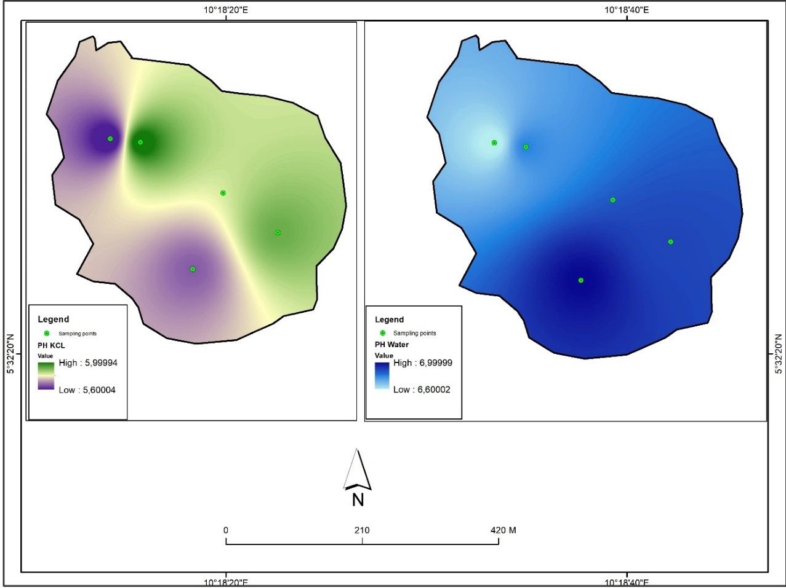
Figure 15: Distribution map of pH kcl and water pH
    - Organic material
The organic matter content is higher in the first centimeters of the soil of the chemical agricultural farm (fig. 17). This could be linked to the topographic position of the farm (lowland) where there would be deposition of soil particles from upstream and therefore greater accumulation of organic matter. Moreover, this organic matter content decreases rapidly (8.85% between 0-20cm and 3.16% between 40-60 cm) yet the organic farming farm ensures consistency throughout this depth (3.86% between 0-20 cm and 3.53% between 40-60 cm). The authors in [14] found identical stability after a 21-year study in organically managed soils compared to chemically managed soils.

Figure 16: Organic material (OM) content
    - Exchangeable cations
The cation balance in tropical soils is 76/18/6 (Ca; Mg; K). The soil samples in the two farms having been taken in a composite way, the determination of the real balance of the cations in the soil was obtained by calculating the relative average of the quantities produced by the analysis results provided by the laboratory. . In general, the different exchangeable cations K, Na, Ca and Mg have high levels in the organic farming farm compared to that of chemical farming.
In farm 1, for the first twenty centimeters of depth, calcium is average, magnesium is high and potassium is low, with respective amounts of 7.3 meq/100g, 6.24 meq/100g and 0.76 meq/100g. The sum of the average exchangeable bases of the soil is 14.63 meq/100g with a real cation balance of 51/43/5. These proportions are reduced by a third in the following 20 cm of depth with the exception of potassium with precisely 5.7 meq/100g for calcium, 4.96 meq/100g of magnesium and 0.8 meq/100g of potassium. The sum of the exchangeable bases being 11.79 meq/100g, for an equilibrium of 49/43/6. This increase in potassium at this level is due to the excessive use of nitrogenous mineral fertilizers, in particular ammonium sulphate which provides 28% of ammoniacal nitrogen due to its formulation in the soil, but also a lot of hydrogen ions which come expel potassium and calcium from the clay-humic complex to relegate it deeper (fig. 18).

Figure 17: Exchangeable cations
The same phenomenon occurs with copper oxide and hydroxide residues which are used in this farm to produce market gardening. Copper deposits on the surface and infiltrates the soil to replace potassium and calcium in the clay-humus complex by isomorphic substitutions. We find ourselves gradually over time with more and more hydrogen and copper ions in the soil. This exposes the plant to copper toxicity in the long run. This operation decreases the pH of the soil in the market gardening farm, bringing it from 7 to 6.9 and 6.7 in places in the farm and increases the exchangeable acidity. The equilibrium values ​​of the exchangeable bases in this soil do not reach the ideal level, in particular with a deficit of 17.69 meq/100g between 0 to 20 cm and 14.33 meq/100g from 20 to 40 cm for calcium, and finally 1.21 meq/100g for potassium from 0 to 20 cm depth.
This permanent deficit pushes the producer to use on a regular basis other complex granular fertilizers rich in Calcium and foliar formulations to meet crop needs each campaign. This has the effect of slowly but gradually deteriorating the fertility of his farm. These additions make it possible to reach approximately the quantities of 24.99 meq/100g and 20.02 meq/100g for calcium, respectively from 0 to 20 cm and from 20 to 40 cm; and 1.97 meq/100g for potassium only from 0 to 20 cm depth. The soil must first take its own quantities of mineral elements to reconstitute itself after each harvest extraction, the farm of farm 1 is therefore constantly in deficit. This creates a progressive dependence which becomes addictive over time, for the use of synthetic chemical fertilizers on the grounds of obtaining immediate results for the satisfaction of the needs of cultivated plants.
In farm 2, the soil contains an average of 9.88 meq/100g of calcium, 6.68 meq/100g of magnesium and 1.59 meq/100g of potassium from 0 to 20 cm. These amounts are medium for calcium, high for magnesium and finally high for potassium. The sum of the real exchangeable bases is 18.43 meq/100 g at this depth, for a cation balance of 54/36/8. Magnesium and potassium are present at proportions above the standard for magnesium and slightly above the level for potassium. The deficit of calcium in this soil is meanwhile glaring.
The observation is the same for the next 20 to 40 cm depth where the calculations show that the calcium is average with 6.44 meq/100g, the average magnesium also with 2.44 meq/100g, and the potassium very high for 3.44 meq/100g of soil. The balance obtained at this level is 52/19/27. The proportion of potassium is much higher than the desired level. Magnesium is very average, slightly above the norm and calcium, although below the desired percentage, is moderately present in the complex. The amounts of magnesium decrease by half, and calcium almost by a third, from 20 to 40 cm, due to the regular cultivation of speculations whose root system is very dense and operates more at this depth.
In view of the topographic position of this farm, we understand that large quantities of potassium, the lightest mineral element of the clay-humic complex, infiltrate abundantly deep into the ground. This explains these high quantities between 20 and 40 cm deep. This parcel therefore loses its exchangeable bases either by erosion or by percolation, in addition to the quantities exported by the crops each year. The sum of the real exchangeable bases of this soil is higher than that of the farm of farm 1 with 18.43 meq/100g against 14.63 meq/100g up to 20 cm and 13 meq/100g against 11.79 meq/100g 20 to 40 cm deep. This means that farm 2 has a larger reservoir in the soil, and a higher cation exchange capacity than farm 1, despite having much less organic matter and nitrogen. Since agroecology is practiced in farm 2, the calcium deficits are made up for by adding manure and compost.
These organic amendments used exclusively in this farm make it possible to increase the negative charge of the clay-humic complex, with the effect of increasing the size of its reservoir for the fixing of exchangeable cations. These organic fertilizers integrated into the soil at maturity, although in insufficient quantities, also provide significant proportions of nitrogen, phosphorus and potassium, in addition to trace elements. This compensates for losses during the crop cycle. Because of the slope, they must supplement at least 53.39 meq/100g of calcium per campaign in the rainy season, i.e. 17.7 meq/100g for the first twenty centimeters of soil and 35.69 meq/100g from 20 to 40cm deep. This content of exchangeable cations is also explained through the following spatial distribution (fig. 19).
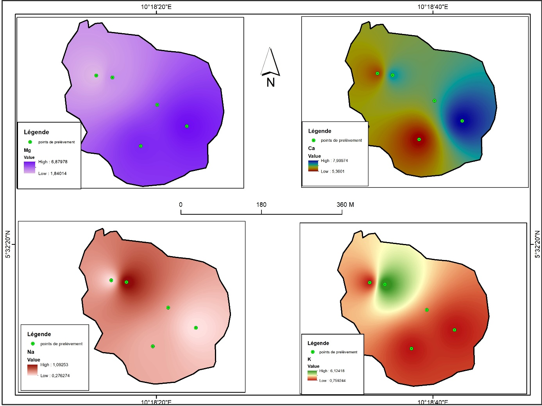
Figure 18: Spatial distribution of exchangeable cations. Parameters used (Mg, Ca, Na, K)
    - Cation exchange capacity and base saturation rate
Evaluation of CEC in farms 1 and 2 was made by saturation of the exchange complex with ammonium ion from ammonium acetate buffered at pH 7. The average soil reaction in the two farms since the water pH is 6.7 to 7, the results obtained in the laboratory by this method of analysis are therefore extremely close to those of the real CEC. For farm 1, the average quantity of cation that the soil can retain on the surface of its aggregates is 17.85 meq/100g for the two depth levels of the profile. According to [15], this value is average. Since CEC is dependent on texture (clay content, fine silt) and organic matter, the type of average soil present (loam) justifies this assessment by high organic matter in the farm.
The percentage of exchangeable cations (Ca, Mg, K and Na) occupied in this CEC is 81% up to 20 cm and 66% from 20 to 40 cm from the ground. These high saturation rates reflect the fact that the exchange complex is fairly well supplied with nutrients for the crop plants compared to the size of the reservoir available in this farm. There is very little site space occupied by exchangeable acidity, including 19% from 0 to 20 cm and 34% from 20 to 40 cm deep. This shift is explained on the one hand by the normal decrease in organic matter at depth and on the other hand by the dissolution of hydronium ions and the saturation of the complex by copper ions in the exchange complex, brought to the soil by synthetic chemical fertilizers (ammonia sulphate) and pesticides (copper oxide and hydroxide) used in this farm. These practices perpetuated with each agricultural campaign gradually compromise the fertility of this farm.
The cation exchange capacity in farm 2 is 21.7 meq/100g from 0 to 20 cm and 19.37 meq/100g from 20 to 40 cm depth. These values, which are high for the surface, and average from 20 to 40 cm, are higher than those of farm 1. This means that the soil complex of farm 2 has a water and mineral element retention capacity larger than that of farm 1. This difference in the size of the volume of the reservoir between the two soils is explained by the regular additions of organic matter which are made each agricultural season in farm 2. These organic fertilizers introduced into this soil free of pesticide residues, decompose quickly and produce the humus necessary for the constitution and reinforcement of the clay-humus complex. This increases the negative charge of the soil for the retention of cations and in passing the cation exchange capacity. Despite a low nitrogen rate and an insufficient amount of organic matter, the base saturation rate present in the soil is high with 84.93% from 0 to 20 cm and 67.11% up to 40 cm deep. Exchangeable acidity occupies only 16% of the sites of the soil complex in the top 20 centimeters of the soil and 32% in the lower level of the profile. With a pH of 6.5 the mineral nutrition of the plants grown in this farm is optimal (fig. 20).

Figure 19: Cation Exchange Capacity (CEC)
The soil of the organic farming farm has a higher CEC and base saturation rate than those of the soil of the chemical farming farm. This could be due to the greater organic matter input in this type of agriculture; this organic matter enriches the clay-humus complex of the soil and thereby increases the amount of exchange sites for cations. Compost and 21-day compost significantly improved exchangeable K, Ca and Mg contents in Nitisol soils of South Africa after one season of application compared to mineral fertilizers at multiple application rates [16]. The authors in [17] report that soil Ca, K, and Mg concentrations and CEC were higher in soils under organic management than in soils under chemical management after two years. These results also support the authors of [18] who obtained similar results by comparing the effects of organic and chemical practices on the physical, chemical and biological properties of the soil. The following distribution map also explain the important cation exchange capacity of organic soil (fig. 21).
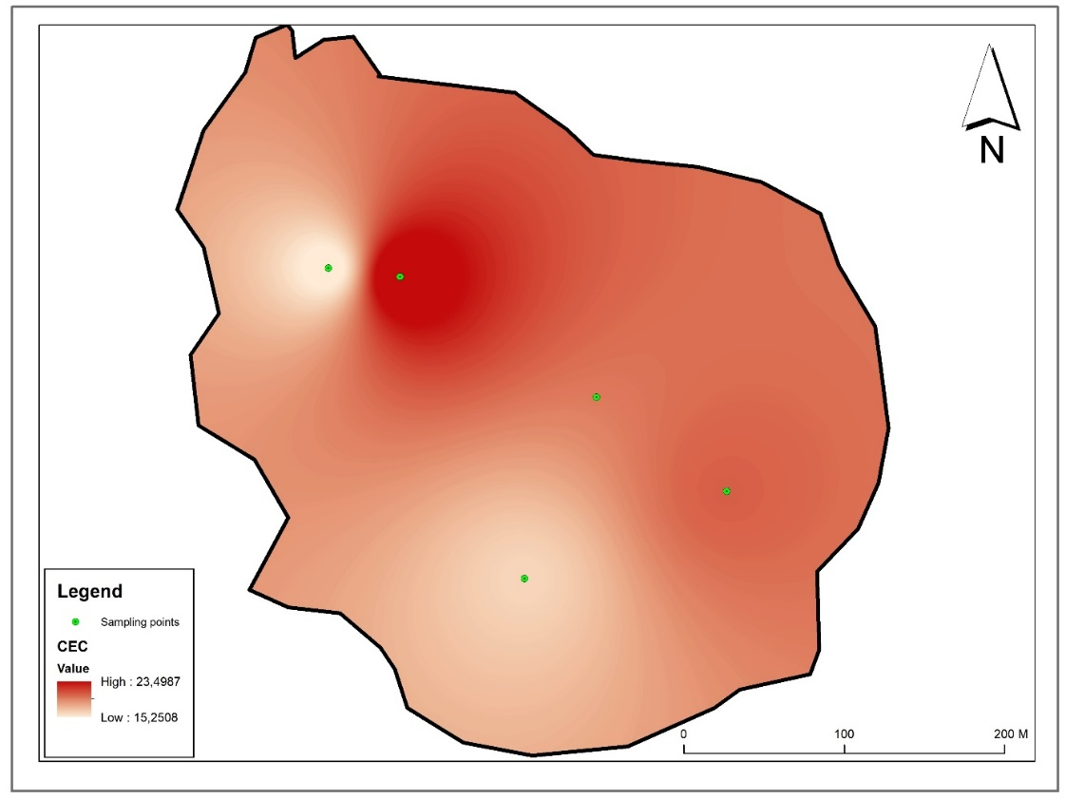
Figure 20: Distribution map of Cation Exchageable Capacity on soils
    - Presence of heavy metals
The heavy metal content is much higher in soils under a chemical farming system compared to soil under an organic farming system, particularly concerning Cu, Ni, Mn and Cr (fig. 22). Fertilizer application could be the cause of this difference. Indeed, these fertilizers would contain dangerous heavy metals [19]. Conversely, organic farming, which relies heavily on natural (organic) fertilizers, has low levels of heavy metals [20].

Figure 21: Diagram of heavy metal content in farms 1 and 2.
The authors of [21] carried out a long-term comparison between a conventional field and an organic field over a period of 16 years in northern Poland. They have thus demonstrated that the ecological practices applied in the organic field have made it possible to significantly increase the nitrogen and carbon content. The minimum tillage in this field has increased, in addition to these two elements, the pH as well as the enzymatic activity. Similarly, a comparison of the long-term effect on the soil of conventional agriculture and organic agriculture has shown that soils that have received organic amendments have better characteristics than those that have been treated conventionally [22]. In addition, soils under conventional agriculture have high yields but soils under organic agriculture make it possible to maintain constant crop yields (ibid. [22]). Author in [23] similarly evaluated the integrated use of organic and inorganic fertilizers on maize cultivation in Andosols of Ethiopia. It follows that the soil after application of organic fertilizers only has a higher pH and nitrogen and phosphorus contents than the soil having received only inorganic fertilizers. Furthermore, he points out that the best maize yield and the best nutrient status of the soil is obtained with an adequate combination of organic and inorganic fertilizers.
- Conclusion
Soil degradation in most Third World regions such as West Cameroon is attributed to poor agricultural practices. If natural factors are unfortunate causes for the deterioration of topsoil, the responsibility of producers is just as notable [24]. The fight against soil degradation is surrounded by the promotion of good agricultural practices which also integrates the consideration of the potentials contained in the environment and the popularization of said good practices [25]. It is a question of identifying and promoting the indigenous knowledge dear to the ancestral heritage of any community and which has very often appeared to be decisive in the process of resilience in the face of exogenous attacks and threats. Despite the multiple agricultural development policies and programs that exist in Cameroon, soil conservation and protection are not given considerable consideration. This lack of regulatory and institutional framework leads to an urgent anarchy on ecosystems and soils [26]. This study wanted to synthesize the knowledge that was retained by the farmers to manage the fertility of their soils. It appears that the main fertility strategies locally retained remain the supply of organic and/or mineral fertilizer and the adoption of cultural practices adapted locally oriented towards agroecology and organic farming. The analysis of local knowledge on fertilizers made it possible to distinguish the types of fertilizers recognized by the farmers and the variables they use to describe them. The knowledge and know-how in terms of the manufacture and use of manures seem acquired, but the actual application on the farms remains limited. The results showed that there is no systematic supply of manures. The doses depend on the availability of capital, the production objectives and the expected effects depending on the type of soil. Soil protection is essential to ensure food security and the right to food [27]. It is becoming increasingly clear that it is necessary to fight more effectively against land degradation in the Anthropocene. Moreover, soil security should become an integral part of the discussion on food security and human security, which is also linked to human rights protection and humanitarian migration processes (ibid. [27]). The challenges before us are global in nature. Thus, any contribution should be used for mutual learning to meet necessities and leave our children and grandchildren with a good place to live. As recommendations, the public authorities should encourage and support the establishment of mechanisms and platforms favorable to the development of local knowledge and know-how, the sharing of experiences and the networking of all actors (producers, research, consumers, businesses, communities, etc.) engaged in agro-ecological transitions [28].
Acknowledgements
This research was carried out thanks to various and multifaceted support and assistance which cannot fully describe here. However, we express a special thanks to:
The Director General of the NGO CIPCRE, the Rev. Dr. Jean-Blaise KENMOGNE, for his support and his agreement to allow me to collect data and information from the beneficiary groups that his organization accompanies;
The Soil Analysis and Environmental Chemistry Laboratory of the FASA of the University of Dschang, for the analysis of soil samples taken from the agricultural plots of Bamendjo;
Mr. TCHOUGONG Alphonse, the president of the association G.NOVIDEB (New Vision Group for the Development of Bamendjo) for his various aids and assistances. He facilitated our access to the different groups of producers;
The producers supervised by the NGO CIPCRE in the Bapa and Bamendjo villages for their assistance, their availability added to their warm and familiar welcome;
Mrs. KOUEKEM Blandine Stéphanie in Bapa and Mrs. SEGNOU Madeleine known as "Ma'a Mado" from Bamendjo, for their remarkable dynamism and their availability to always share their knowledge and tips with other producers.
References
[1]. Dounias, E., 2015, ‘‘Des savoirs locaux revisités. Changement climatique : quels défis pour le sud ?’’, Institut de Recherche pour le Développement, Marseille 2015.
[2]. Sambo, A. (2014). ‘‘Vulgarisation des savoirs locaux agricoles comme stratégies d’adaptation au Changement climatique dans la région de l’Extrême Nord du Cameroun’’. Spécial hors-série n° 1, Science et technique, Lettres, Sciences sociales et humaines, pp 173-185.
[3]. Malaval, C., Jouy, L., Desvignes, P., Carpy-Goulard, F., et Dumont, A. (2011). ‘‘Quelles sont les pratiques agricoles les plus « durables » ?’’ Essai de caractérisation des systèmes de cultures. Sciences Eaux & Territoires, Numéro 4, p. 8-14.
[4]. Baillargeon, S. (2015, 11 juin). ‘‘Dégradation des sols en agriculture’’. Ecologie, Internet : http://www.economiesolidaire.com/2015/06/11/la-degradation-des-sols-en-agriculture/ [April 19, 2021]
[5]. Sall, Ch. T., Fall, M., Ba Mbow, A. F., & Gueye, B. (2011). ‘‘Résilience et Innovation Locale face aux Changements Climatiques’’, Capitalisation des résultats du programme "Fonds de Soutien aux Stratégies Locales d’Adaptation (FSSA) ". IED Afrique.
[6]. J. B. K. Vodounou and D. Y. Onibon, Agriculture paysanne et stratégies d’adaptation au changement climatique au Nord-Bénin. European Journal of Geography, N° 794, 2016.
[7]. M. A. Stocking and N. Murnaghan. ‘‘Handbook for the Field Assessment of Land Degradation’’. Earthscan, London, 2001.
[8]. M. Mustin, ‘‘Le compostage des déchets organiques : quelques applications agronomiques et environnementales’’, RITTMO (Recherche Innovation Transfert de Technologie pour les Matières fertilisantes Organiques), ENSA, Toulouse, 2018.
[9]. M. Hébert et B. Breton. ‘‘Recyclage agricole des cendres de bois au Québec - État de la situation, impacts et bonnes pratiques agro-environnementales’’. AGROSOLUTIONS, Vol. 19 N°2, Décembre 2008.
[10]. P. M. Coleman, ‘‘Land application of wood ash: 12 years in northern New England’’, In: Symposium on land application of wood-fired and combination boiler ashes, 1995, NCASI meetings, Asheville, North Carolina, August 2-3, p. 4-6.
[11]. T. Gebreegziabher, J. Nyssen, B. Govaerts, F. Getnet, M. Behailu, M. Haile and J. Deckers. ‘‘Contour furrows for in situ soil and water conservation’’, Tigray, Northern Ethiopia. Soil and Tillage Research, 103(2), 2009, Pp. 257-264.
[12]. S. De Alba, C. Lacasta, G. Benito and A. Perez-Gonzalez. ‘‘Influence of soil management on water erosion in a Mediterranean semiarid environment in Central Spain’’. In: I World Congress on Conservation Agriculture, Madrid, Spain, 2001, Pp. 158–165
[13]. T. Erkossa, K. Stahr and T. Gaiser. ‘‘Effect of different methods of land preparation on run off, soil and nutrient losses from a Vertisol in the Ethiopian highlands’’. Soil Use Manage. 21, 2005, Pp. 253–259.
[14]. P. Mader, A. Fließbach, D. Dubois, L. Gunst, P. Fried and U. Niggli. ‘‘Soil fertility and biodiversity in organic farming’’. Science. 296, 2002, Pp. 1694–1697.
[15]. G. Collaud, J.-P. Ryser et J.-J. Schwarz. ‘‘Capacité d’échange
des cations’’. Revue suisse d’agriculture 22 (5), 1990, Pp. 285–289.
[16]. G. Agegnehu, P. N. Nelson, M. I. Bird. ‘‘Crop yield, plant nutrient uptake and soil physicochemical properties under organic soil amendments and nitrogen fertilization on Nitisols’’. Soil Tillage Res. 160, 2016, Pp. 1–13.
[17]. L. R. Bulluck and J. B. III Ristaino. ‘‘Effect of synthetic and organic soil fertility amendments on Southern blight, soil microbial communities, and yield of processing tomatoes’’. Phytopathology. 92, 2002, Pp. 181–189.
[18]. B. Liu, C. Tu, S. Hu, M. Gumpertz and J. B. Ristaino. ‘‘Effect of organic, sustainable, and conventional management strategies in grower fields on soil physical, chemical, and biological factors and the incidence of Southern Blight’’. Appl. Soil Ecol. 2007, 37, 2007, Pp. 202–214.
[19]. J. A. Chandana and W. Jagath. ‘‘Review of organic and conventional agricultural products: Heavy metal availability, accumulation and safety’’. Int. J. Food Sci. and Nutr. 4(1), 2018, Pp. 77-88.
[20]. C. Zaccone, R. Di Caterina, T. Rotunno, and M. Quinto. ‘‘Soil– farming system–food–health: Effect of conventional and organic fertilizers on heavy metal (Cd, Cr, Cu, Ni, Pb, Zn) content in semolina samples’’. Soil and Tillage Research. 107(2): 2010, Pp. 97-105.
[21]. M. Kobierski, J. Lemanowicz, P. Wojewódzki, and K. Kondratowicz-Maciejewska. ‘‘The effect of organic and conventional farming systems with different tillage on soil properties and enzymatic activity’’. Agronomy, 10 (11), 1809, 2020.
[22]. J. P. Reganold, L. F. Elliott and Y. L. Unger. ‘‘Long-term effects of organic and conventional farming on soil erosion’’. Nature, 330(6146), 1987, Pp. 370-372.
[23]. M. H. Sigaye. “Integrated use of organic and inorganic fertilizers on maize (zea mays l.) yield and soil fertility in andisols of sidama’’, Ethiopia, 2020.
[24]. C. Pautrot. ‘‘Érosion et dégradation des sols’’. Mémoires de l’Académie Nationale de Metz, France, 2012.
[25]. K. Prager, J. Schuler, K. Helming, P. Zander, T. Ratinger and K. Hagedorn. “An analytical framework for soil degradation, farming practices, institutions and policy responses”, Paper prepared for presentation at the EAAE 2011 Congress Change and Uncertainty Challenges for Agriculture, Food and Natural Resources, August 30 to September 2, 2011, ETH Zurich, Zurich, Switzerland.
[26]. N. Ravonjiarison, E. Penot, A. Albrecht et T. Razafimbelo. ‘‘Savoirs locaux et stratégies paysannes autour de la fertilité des sols au lac Alaotra’’, Madagascar, 25, 2018, Pp. 29-41.
[27]. O. C. Ruppel. ‘‘Soil protection and the right to food: sustainability implications for global climate governance and world agricultural trade?’’, Nomos, Baden-Baden, 2021, pp. 499-528.
[28]. Agronome et Vétérinaire Sans Frontière (AVSF). ‘‘Transitions agro-écologiques et agricultures paysannes’’. Note de positionnement. www.avsf.org, Juillet 2019.

